**Between minimized spread factor and Sat night spread - add .1 for flight 5**

**[1.7, 1.2, .7, .45, .1]**

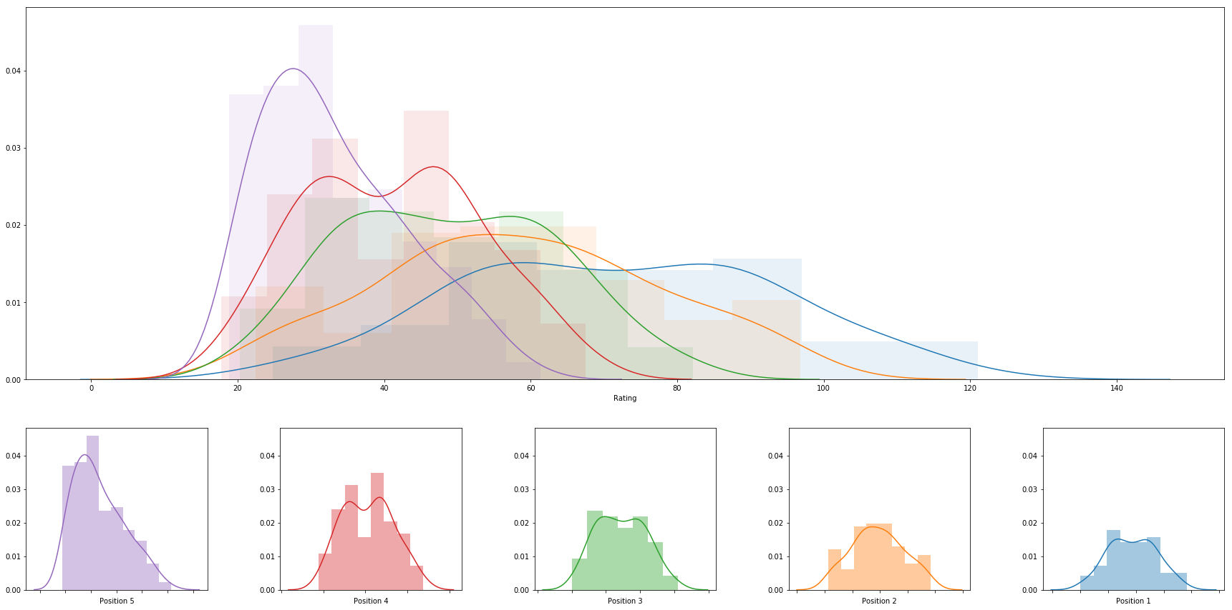

|  |  |  |  |  |  |  |  |
| --- | --- | --- | --- | --- | --- | --- | --- |
|  | **rank** | **name** | **college** | **division** | **rating** | **primary position** | **last date of play** |
| **0** | 1 | Abril Bustamante | USC | DI | 121.02363313062074 | 1 | 2018-05-05 |
| **1** | 2 | Megan McNamara | UCLA | DI | 111.47575174607339 | 1 | 2018-05-06 |
| **2** | 3 | Nicole McNamara | UCLA | DI | 111.47575174607339 | 1 | 2018-05-06 |
| **3** | 4 | Emily Maglio | Hawaii | DI | 110.39157369592559 | 1 | 2018-05-06 |
| **4** | 5 | Ka'iwi Schucht | Hawaii | DI | 110.39157369592559 | 1 | 2018-05-06 |
| **5** | 6 | Tina Graudina | USC | DI | 109.19717772579308 | 1 | 2018-05-05 |
| **6** | 7 | Victoria Paranagua | Florida State | DI | 109.00391613884828 | 1 | 2018-05-05 |
| **7** | 8 | Claire Coppola | LSU | DI | 105.81065521506092 | 1 | 2018-05-04 |
| **8** | 9 | Kristen Nuss | LSU | DI | 105.81065521506092 | 1 | 2018-05-04 |
| **9** | 10 | Vanessa Freire | Florida State | DI | 102.69582826601903 | 1 | 2018-05-05 |
| **10** | 11 | Nele Barber | Long Beach State | DI | 101.43493667467979 | 1 | 2018-04-28 |
| **11** | 12 | Sasha Karelov | Long Beach State | DI | 100.97835629532503 | 1 | 2018-04-28 |
| **12** | 13 | Madeline Mertz | Tulane | DI | 100.36740792064113 | 1 | 2018-04-21 |
| **13** | 14 | Kaylie Mchugh | Tulane | DI | 100.36740792064113 | 1 | 2018-04-21 |
| **14** | 15 | Teegan Van Gunst | Georgia State | DI | 97.95359617665675 | 1 | 2018-04-21 |
| **15** | 16 | Katie Smith | South Carolina | DI | 96.7701542227091 | 2 | 2018-05-04 |
| **16** | 17 | Sunny Villapando | Stanford | DI | 95.83676337886074 | 1 | 2018-04-27 |
| **17** | 18 | Corinne Quiggle | Pepperdine | DI | 94.66893725948114 | 2 | 2018-05-05 |
| **18** | 19 | Deahna Kraft | Pepperdine | DI | 94.66893725948114 | 2 | 2018-05-05 |
| **19** | 20 | Federica Frasca | FIU | DI | 94.40098638089853 | 1 | 2018-05-04 |
| **20** | 21 | Margherita Bianchin | FIU | DI | 94.40098638089853 | 1 | 2018-05-04 |
| **21** | 22 | Mima Mirkovic | Cal | DI | 94.33138248704145 | 1 | 2018-04-28 |
| **22** | 23 | Annika Van Gunst | Georgia State | DI | 93.68872165639215 | 1 | 2018-04-21 |
| **23** | 24 | Jessica Wooten | Houston Baptist | DI | 93.480203938869 | 1 | 2018-04-22 |
| **24** | 25 | Aeriel Horton | Houston Baptist | DI | 93.480203938869 | 1 | 2018-04-22 |
| **25** | 26 | Rachel Nieto | Long Beach State | DI | 92.62274269544945 | 2 | 2018-04-28 |
| **26** | 27 | Lily Justine | UCLA | DI | 91.58245006977353 | 2 | 2018-05-06 |
| **27** | 28 | Sarah Sponcil | UCLA | DI | 91.58245006977353 | 2 | 2018-05-06 |
| **28** | 29 | Morgan Martin | Hawaii | DI | 91.03828769433476 | 2 | 2018-05-06 |
| **29** | 30 | Dani Barton | Utah | DI | 90.78654561994342 | 1 | 2018-04-27 |
| **30** | 31 | Adore Anae | Utah | DI | 90.78654561994342 | 1 | 2018-04-27 |
| **31** | 32 | Katie Horton | Florida State | DI | 89.6035651304789 | 2 | 2018-05-05 |
| **32** | 33 | Lea Monkhouse | Hawaii | DI | 89.37911954268911 | 2 | 2018-05-06 |
| **33** | 34 | Torrey Van Winden | Cal Poly SLO | DI | 89.06935093806271 | 1 | 2018-04-28 |
| **34** | 35 | Tia Miric | Cal Poly SLO | DI | 89.06935093806271 | 1 | 2018-04-28 |
| **35** | 36 | Sammy Slater | USC | DI | 88.98167440415936 | 2 | 2018-05-05 |
| **36** | 37 | Terese Cannon | USC | DI | 88.91163238787952 | 2 | 2018-05-05 |
| **37** | 38 | Alexia Inman | Cal | DI | 88.32217609792954 | 1 | 2018-04-28 |
| **38** | 39 | Hailey Luke | Florida State | DI | 87.85422156496335 | 2 | 2018-05-05 |
| **39** | 40 | Brook Bauer | Pepperdine | DI | 87.642846319982 | 1 | 2018-05-05 |
| **40** | 41 | Madalyn Roh | Pepperdine | DI | 87.642846319982 | 1 | 2018-05-05 |
| **41** | 42 | Olivia Macdonald | Arizona | DI | 87.5914009682459 | 1 | 2018-04-27 |
| **42** | 43 | Natalie Anselmo | Arizona | DI | 87.5914009682459 | 1 | 2018-04-27 |
| **43** | 44 | Shannon Williams | South Carolina | DI | 87.38756869742092 | 1 | 2018-05-04 |
| **44** | 45 | Ali Denney | South Carolina | DI | 87.38756869742092 | 1 | 2018-05-04 |
| **45** | 46 | Jordan Anderson | Washington | DI | 86.25128902572303 | 1 | 2018-04-28 |
| **46** | 47 | Kimmy Gardiner | Washington | DI | 86.25128902572297 | 1 | 2018-04-28 |
| **47** | 48 | Morgan Hughes | Saint Mary's | DI | 85.8624894208736 | 1 | 2018-04-21 |
| **48** | 49 | Payton Rund | Saint Mary's | DI | 85.8624894208736 | 1 | 2018-04-21 |
| **49** | 50 | Sammee Thomas | Stetson | DI | 84.79690193450868 | 1 | 2018-04-21 |
| **50** | 51 | Darby Dunn | Stetson | DI | 84.79690193450868 | 1 | 2018-04-21 |
| **51** | 52 | Cadie Bates | South Carolina | DI | 84.34136896118976 | 2 | 2018-05-04 |
| **52** | 53 | Nicole Lott | UNC Wilmington | DI | 84.04836760002607 | 1 | 2018-04-21 |
| **53** | 54 | Maddy Kline | UNC Wilmington | DI | 84.04836760002607 | 1 | 2018-04-21 |
| **54** | 55 | Savannah Slattery | LMU | DI | 83.74163316544504 | 1 | 2018-04-21 |
| **55** | 56 | Jessica Gaffney | Cal | DI | 83.5678460027418 | 2 | 2018-04-28 |
| **56** | 57 | Emily Sonny | Cal Poly SLO | DI | 83.56511264228088 | 2 | 2018-04-28 |
| **57** | 58 | McKayla Ferris | LMU | DI | 83.29422141491516 | 1 | 2018-04-21 |
| **58** | 59 | Molly Turner | Grand Canyon | DI | 82.88157338354651 | 1 | 2018-04-19 |
| **59** | 60 | Haleigh Nelson | LSU | DI | 82.21913433831338 | 2 | 2018-05-04 |
| **60** | 61 | Carly Kan | Hawaii | DI | 82.12581895837283 | 3 | 2018-05-06 |
| **61** | 62 | Haven Hill | TCU | DI | 82.07261866580171 | 1 | 2018-04-15 |
| **62** | 63 | Cassie House | TCU | DI | 82.07261866580171 | 1 | 2018-04-15 |
| **63** | 64 | Devon May | UAB | DI | 81.96751679934987 | 1 | 2018-04-21 |
| **64** | 65 | Kenley Adams | UAB | DI | 81.92050351994675 | 1 | 2018-04-21 |
| **65** | 66 | Sam Manley | Cal Poly SLO | DI | 81.91647187853106 | 2 | 2018-04-28 |
| **66** | 67 | Amelia Smith | Stanford | DI | 81.64680632355989 | 2 | 2018-04-27 |
| **67** | 68 | Morgan Hentz | Stanford | DI | 81.64680632355989 | 2 | 2018-04-27 |
| **68** | 69 | Courtney Schwan | Washington | DI | 80.53126022253387 | 2 | 2018-04-28 |
| **69** | 70 | Destiny Julye | Washington | DI | 80.38827289642734 | 2 | 2018-04-28 |
| **70** | 71 | Laurel Weaver | Hawaii | DI | 80.27841467240945 | 3 | 2018-05-06 |
| **71** | 72 | Hannah Towne | Grand Canyon | DI | 79.89534118686187 | 1 | 2018-04-19 |
| **72** | 73 | Tiffany Creamer | Georgia State | DI | 79.83477248031797 | 2 | 2018-04-21 |
| **73** | 74 | Sara Putt | Florida State | DI | 78.99128573894255 | 3 | 2018-05-05 |
| **74** | 75 | Carly Scarborough | FAU | DI | 78.55931676639662 | 1 | 2018-04-21 |
| **75** | 76 | Megan Kruidhof | Long Beach State | DI | 77.06331160563789 | 2 | 2018-04-28 |
| **76** | 77 | Iya Lindahl | Cal | DI | 76.97763653825771 | 2 | 2018-04-28 |
| **77** | 78 | Courtney Bowen | Stanford | DI | 76.54323845100492 | 3 | 2018-04-27 |
| **78** | 79 | Jessie Prichard | LMU | DI | 76.35836552566003 | 2 | 2018-04-21 |
| **79** | 80 | Macy Jerger | Florida State | DI | 75.78015778658278 | 3 | 2018-05-05 |
| **80** | 81 | Brooke Weiner | Georgia State | DI | 75.6627468129005 | 2 | 2018-04-21 |
| **81** | 82 | Sara Kovac | LMU | DI | 75.60380851635968 | 2 | 2018-04-21 |
| **82** | 83 | Katja Ehlers | College of Charleston | DI | 75.57882679327116 | 1 | 2018-04-21 |
| **83** | 84 | Emily Bible | Saint Mary's | DI | 75.5544254334131 | 2 | 2018-04-21 |
| **84** | 85 | Lindsey Knudsen | Saint Mary's | DI | 75.5544254334131 | 2 | 2018-04-21 |
| **85** | 86 | Amanda Silva | FAU | DI | 75.44346456684042 | 1 | 2018-04-21 |
| **86** | 87 | Sunniva Helland-Hansen | Stetson | DI | 74.67170445054462 | 2 | 2018-04-21 |
| **87** | 88 | Carly Perales | Stetson | DI | 74.67170445054462 | 2 | 2018-04-21 |
| **88** | 89 | Sabryn Roberts | Boise State | DI | 74.3754118226024 | 1 | 2018-04-21 |
| **89** | 90 | Janell Walley | Boise State | DI | 74.3754118226024 | 1 | 2018-04-21 |
| **90** | 91 | Carina Hoff | UNF | DI | 74.07564794187171 | 1 | 2018-04-21 |
| **91** | 92 | Courtney Miller | UNF | DI | 74.07564794187171 | 1 | 2018-04-21 |
| **92** | 93 | Haley Hallgren | USC | DI | 73.10099032295943 | 3 | 2018-05-05 |
| **93** | 94 | Savvy Simo | UCLA | DI | 72.91825573011228 | 3 | 2018-05-06 |
| **94** | 95 | Megan Nash | Central Arkansas | DI | 72.66650634125874 | 1 | 2018-04-22 |
| **95** | 96 | Hayley Tippett | Central Arkansas | DI | 72.66650634125874 | 1 | 2018-04-22 |
| **96** | 97 | Mackenzie Allen | FGCU | DI | 72.50698512861308 | 1 | 2018-04-21 |
| **97** | 98 | Amanda Carroll | FGCU | DI | 72.50698512861308 | 1 | 2018-04-21 |
| **98** | 99 | Krissy Mummey | College of Charleston | DI | 72.39832008152479 | 1 | 2018-04-21 |
| **99** | 100 | Tarin Mergener | Tulane | DI | 72.26517177064974 | 2 | 2018-04-21 |